**FR. Conceicao Rodrigues College Of Engineering**

Father Agnel Ashram, Bandstand, Bandra-west, Mumbai-50

**Department of Computer Engineering**

**S.E. (Computer) (semester IV)**

**(2019-2020)**

# MINI PROJECT REPORT

## Subject: Operating System Semester: IV

## Incharge: Prof. Mahendra Mehra Date: 31st March 2019-20

# Title: Women Safety Android App

# Team members: Simran Biswas(8591),Chelsea Dabre(8597),Celine D’silva(8602)

# Abstract: The heinous rape incidents have waken us to go for the safety issues and so a host of new apps have been developed to provide security systems to women via their phones. This Android Application for the Safety of Women can be activated by just shaking the phone, whenever need arises. Through this App you can register the name and contact number of people you want to be notified. This app identifies the location of place through GPS and sends a message comprising this location URL in dangerous situations. The unique feature of this application is to send the message to the registered contacts immediately when we shake the phone. Continuous location tracking information via SMS helps to find the location of the victim quickly and can be rescued safely.

**Features:**

* Stores the records of all the people to be notified in case of emergency.
* Allows you to add more contacts to the list.
* Just by shaking the phone the app is triggered and the contact list members get an indication.
* With the help of GPS the exact location is obtained.

**Technology:**

We have used Android Studio to build the app.

**Outcome:**

This app ensures a sense of safety amongst Women considering the heinous incidents happening around. Once notified through this app immediate actions can be taken to atleast avoid the worst scenario.

**Screenshots:**

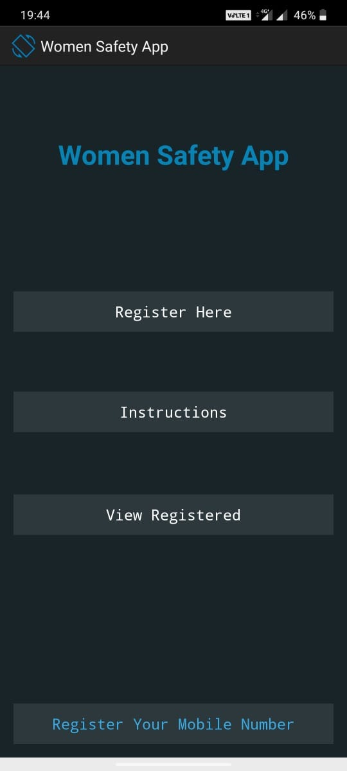 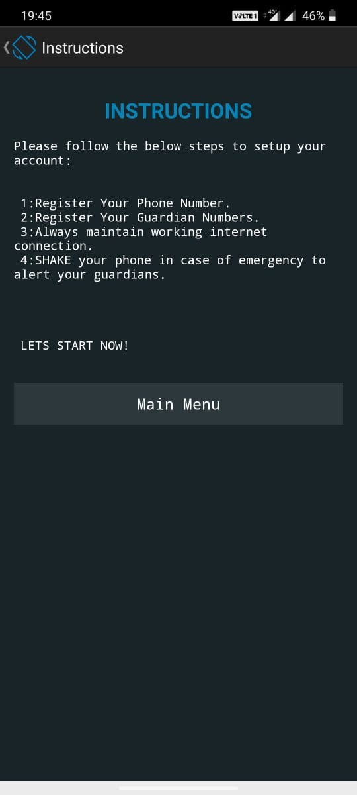

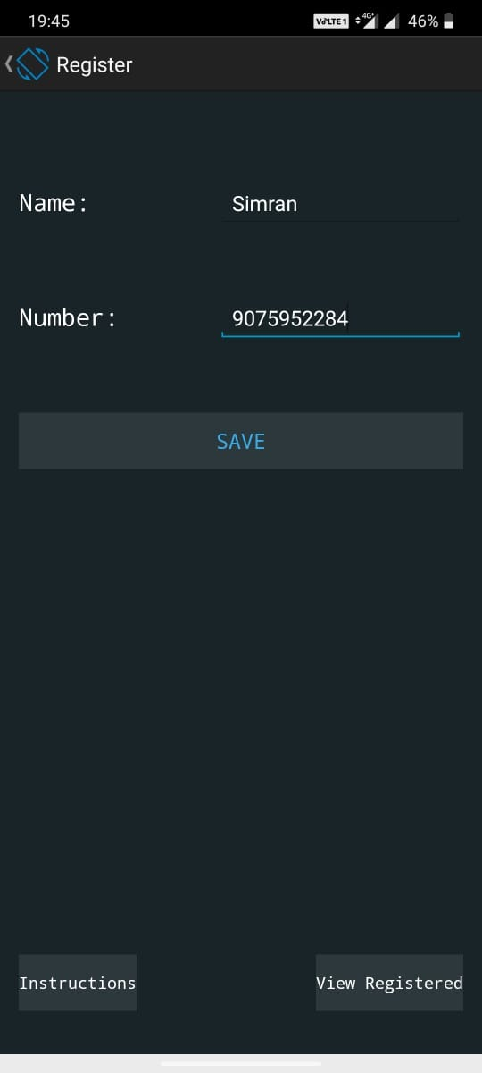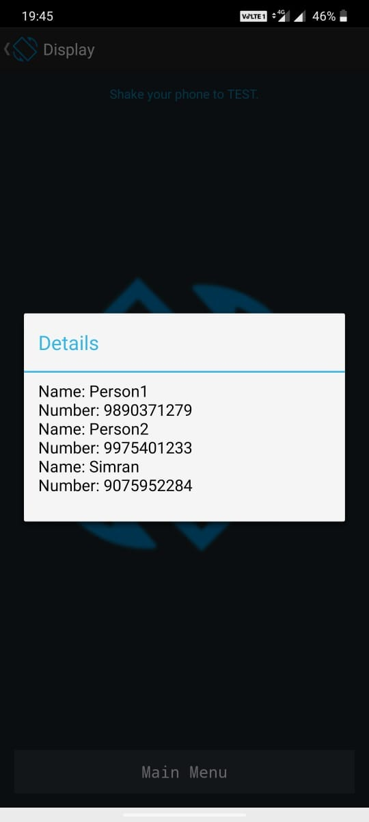

**Conclusion:**

We were able to successfully implement an app by using Android Studio. This app is very useful for women and through this we can successfully alert the guardians.

**References:**

<https://www.gadgetsnow.com/slideshows/7-best-women-safety-apps/>

<https://www.coursera.com/full-stack-app-development/>

<https://www.beanstalkmums.com/>